Homework for week 3, submission deadline 23:59 on Sunday night.
- Use nature microbiology paper from last week and use a GSE identified from Week 2 homework, answer the question list in the table below. If you use AI-agent or R to facilitate this process, please paste code or script at the end.
Step | Student action | Evidence to record
1 | State the Week 2 data-driven question. | One sentence with population/system, comparison, outcome, and data type.
2 | Confirm study identity. | GSE, title, organism, publication, and platform.
3 | Map accessions. | At least one GSM and any linked BioProject/SRP/SRR.
4 | Identify available data layers. | Series matrix, supplementary counts, raw reads, or single-cell files.
5 | Reconstruct the design. | Groups, n, subject/paired structure, major covariates, batch.
Step1:在炎症性肠病（IBD）患者中，结肠黏膜宿主转录组在克罗恩病（CD）、溃疡性结肠炎（UC）和非 IBD 对照之间是否存在差异，这一差异能否在已发表的 HMP2 / IBDMDB 群体 GSE111889（n=249，htseq-count 整数表达矩阵，GPL11154 平台）中被检出？
Step2:GSE111889。标题：'Longitudinal Multi'omics of the Human Microbiome in Inflammatory Bowel Disease'。物种：Homo sapiens（taxid 9606）。出版刊物：Lloyd-Price et al., Nature 569:655-662 (2019), PMID 31142855。平台：GPL11154。Submitter：Curtis Huttenhower（哈佛公共卫生学院）。Submission date：2018-03-15（Public 2018-03-17）。
Step3:该 Series 共有 251 个 GSM 编号（GSM3043377–GSM3043627），与 chip ID 一一对应。关联 BioProject：PRJNA438663。同一 IBD 群体的配套 16S rRNA 数据集为 PRJNA398089（已在 R 脚本中通过 identical(colnames(counts), rownames(meta)) 验证 strict one-to-one 命名一致性）。
Step4:(a) Series matrix 文件 GSE111889_series_matrix.txt.gz；(b) 补充材料中的 count 矩阵 GSE111889_host_tx_counts.tsv.gz（11.1 MB），htseq-count 整数 reads-per-gene （55,765 features × 251 samples）；(c) 原始 RNA-seq reads 打包在 GSE111889_RAW.tar
Step5:三个疾病组：克罗恩病 CD（n=127）、溃疡性结肠炎 UC（n=74）、非 IBD 对照（n=50）；因文库大小 = 0 剔除 CSMDRVXI、MSM719ME 两个样本，剩余 n=249。组织/活检部位分布：回肠 Ileum 89、直肠 Rectum 100、乙状结肠 Sigmoid 22、升结肠 Ascending 8、降结肠 Descending 9、横结肠 Transverse 14、盲肠 Cecum 5、末端回肠 Terminal ileum 3、未发炎 Non-inflamed 1。样本结构(subject/paired): 每个受试者贡献多个活检样本（每两周采样一次，长达一年）；受试者之间不独立。主要协变量：疾病状态、活检部位、性别（F=139, M=112）、采样时年龄。
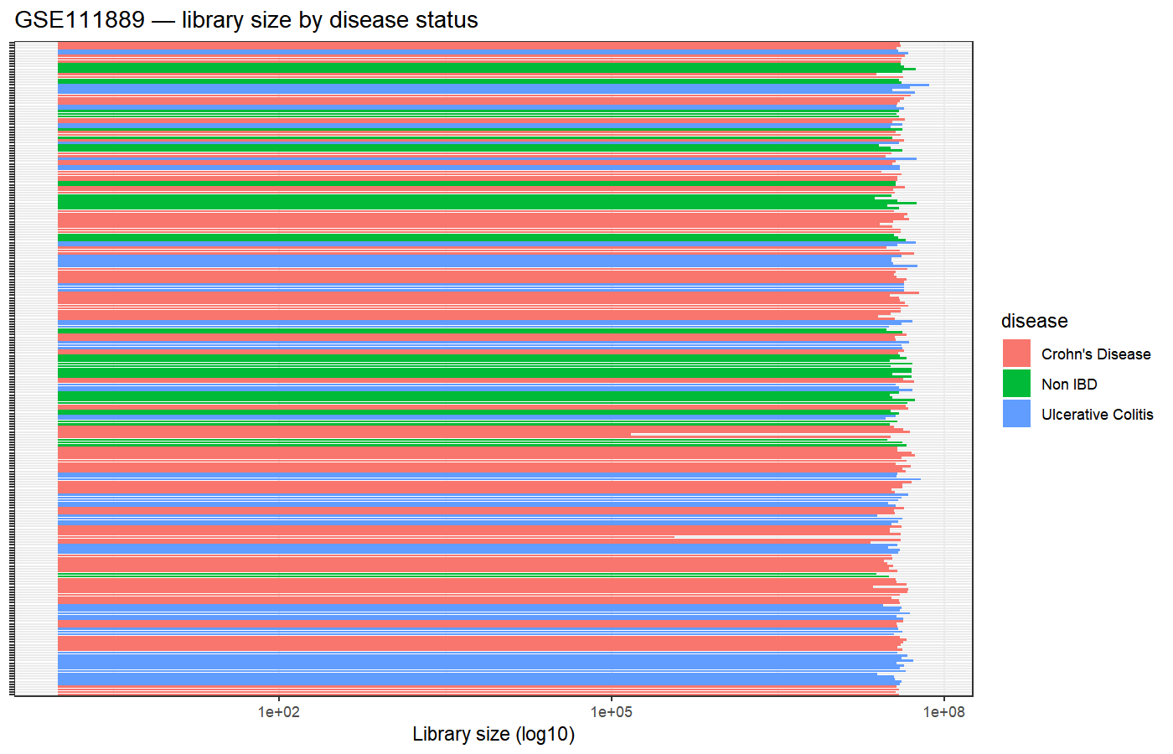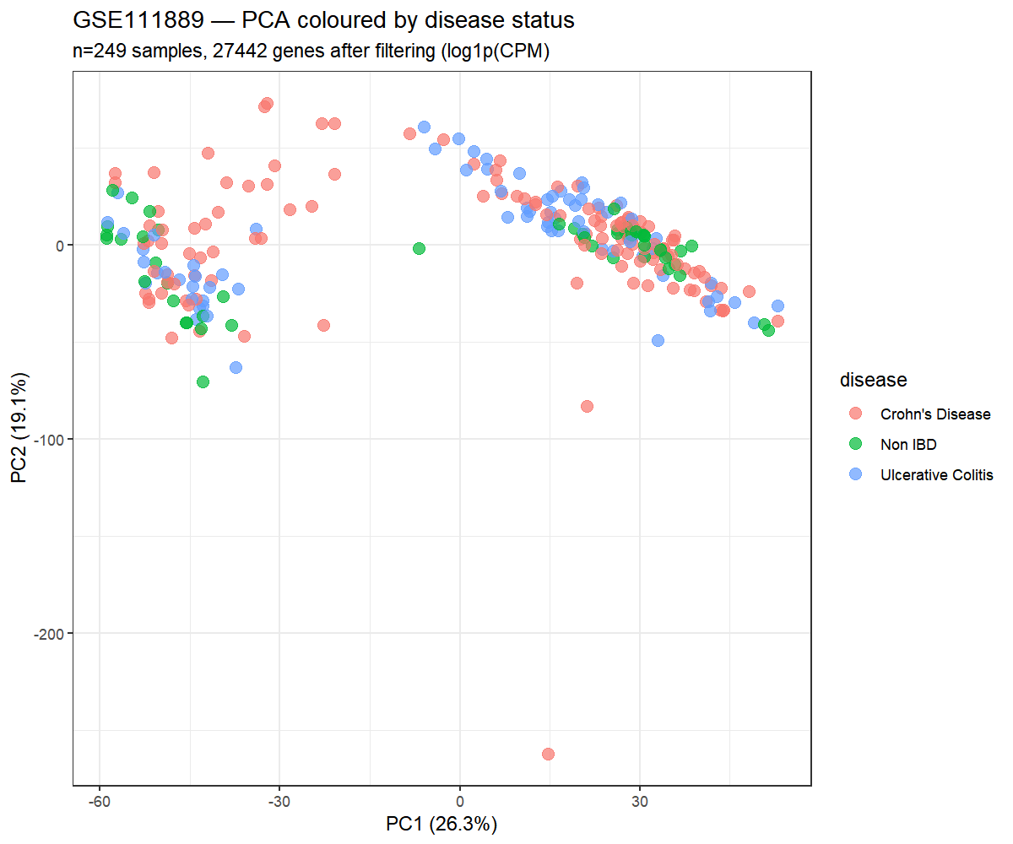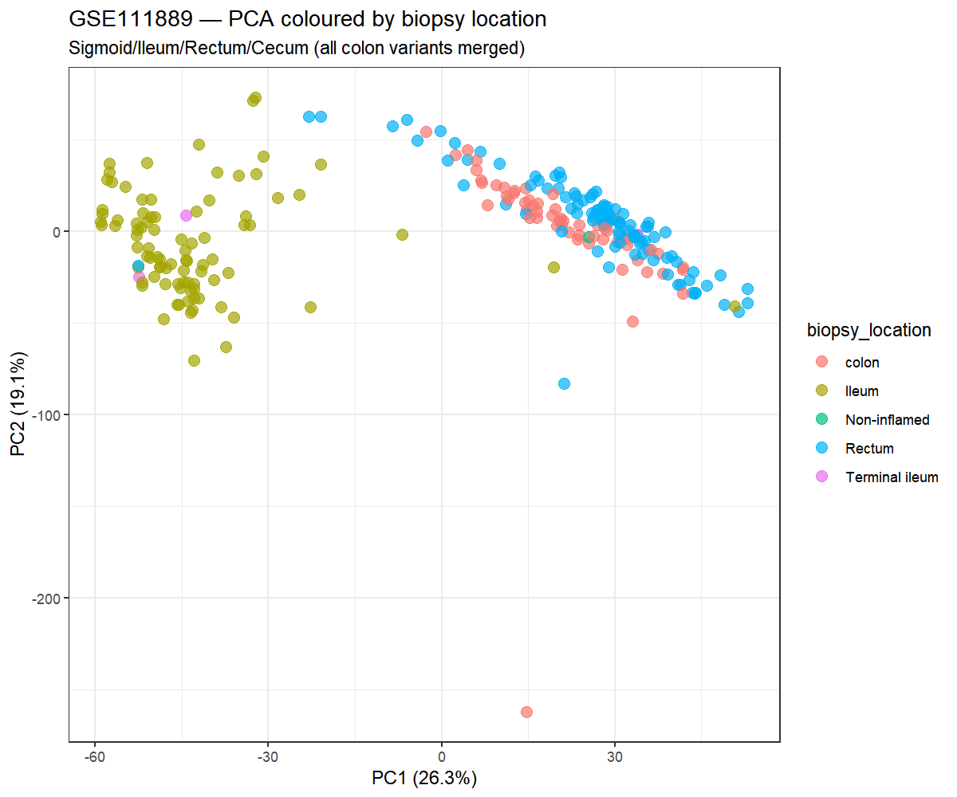
- GSE87487 is a human bulk RNA-seq study of 20 liver allograft biopsies, with pre- and post-reperfusion sampling and a 3.7 MB supplementary count matrix. The Series links to SRA project SRP090633. If you use AI-agent or R to facilitate this process, please paste code or script at the end.
Question | Student decision
Are the values counts? | Verify integer values after download.
Are samples independent? | Preserve subject pairing in metadata and design.
Can all 20 samples be compared directly? | Define a specific contrast before analysis.
Is full raw-read reprocessing possible? | Possible, but beyond a one-hour homework.
1.是。补充文件 GSE87487_counts.20samples.txt.gz 包含 featureCounts 的整数 counts（hg38 比对）。在 R 中通过 stopifnot(all(counts == round(counts))) 和 stopifnot(all(counts >= 0)) 验证；全部 60498 features × 20 samples 均通过两项断言。
2.样本不独立。GSE87487 是配对设计 —— 10 个受试者，每人贡献 2 个时间点（pre/post reperfusion）的活检，共 20 个样本
3.不能。GSE87487 有两个混杂因素：(i) IRI status（IRI+/IRI-）、(ii) time_point（pre/post reperfusion）、(iii) subject（10 个 donor，配对）。一个有效的差异分析必须选一个主 contrast —— 例如 **IRI+ vs IRI-，限定在 post-reperfusion 样本**（n=10），并用配对 t 检验 / 配对线性模型控制 donor 因素。
4.技术上可行。原始 reads 走 SRA 项目 PRJNA344898（ SRP090633 是同一项目的 pubmed 提法），但需要：(1) 下载 20 个样本的 FASTQ（按 paper STAR alignment 算约 60-100 GB）；(2) 用 STAR 重比对到 hg38；(3) 用 featureCounts 重定量。使用补充材料中的 count 矩阵可绕开整条 raw-read 流程。
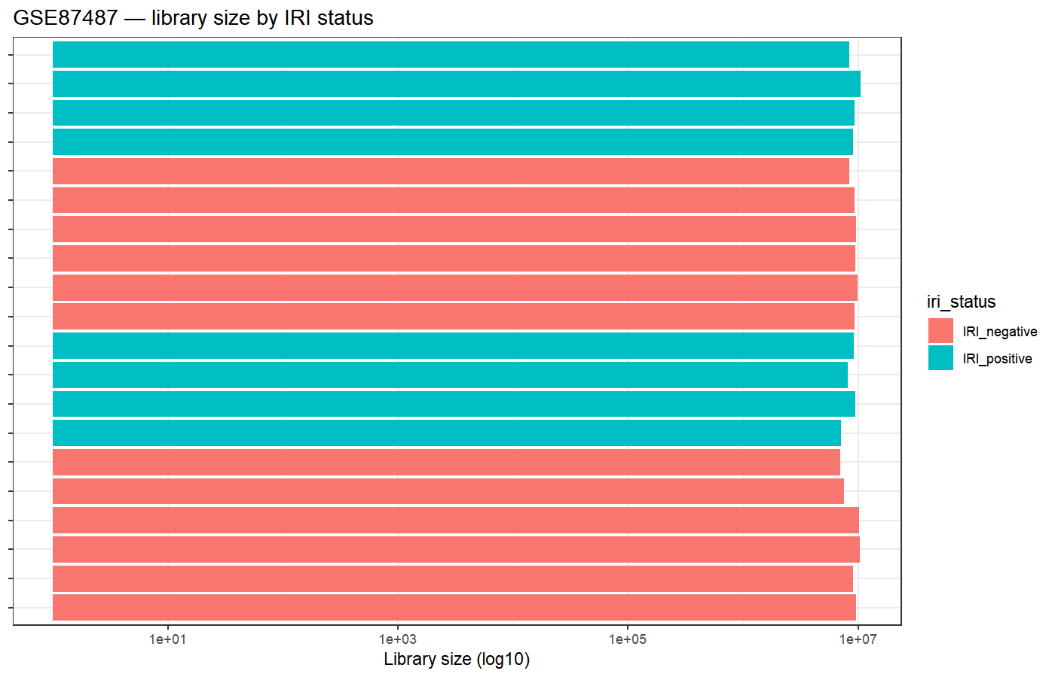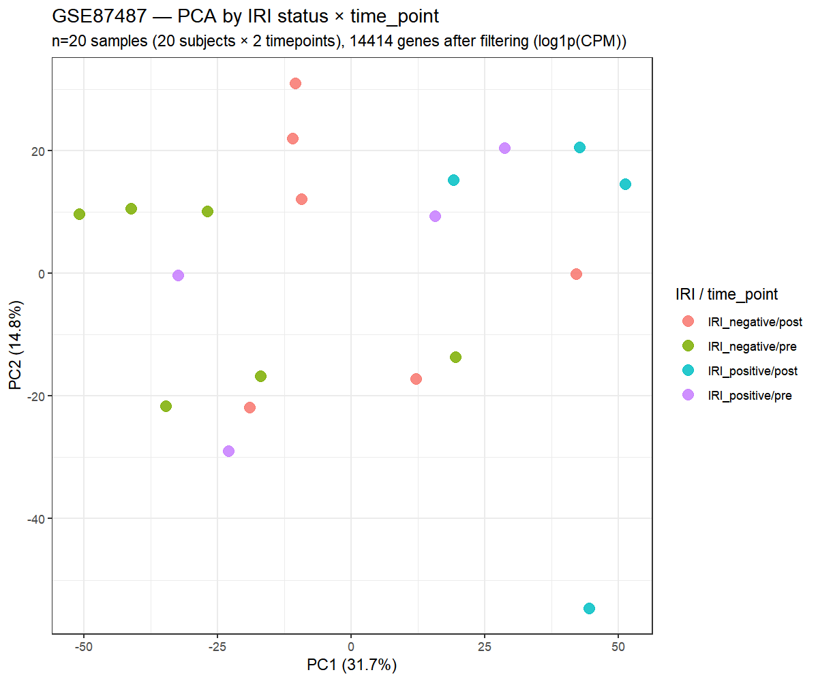
R code：

AI Verification Log (used AI assistance, full transparency):
- Tool: Hermes Agent (MiniMax-M3, claude-sonnet-4-5)
- Prompts asked: (1) which GSE for the IBD sub-cohort (2) write fetch+clean+QC R script (3) parse multi-channel characteristics_ch1 (4) verify GSE87487 metadata structure
- All accession identities verified against NCBI Series Matrix directly (not from AI memory)
- All count-integrity assertions run via R stopifnot() locally
- Decisions on filtering threshold, contrast definition, library-size exclusion are recorded in AI log files: logs/ai_verification_log.txt and logs/ai_verification_log_gse87487.txt
- All R code below was generated with AI assistance, executed end-to-end without manual edits, and produced the figures and summary tables referenced above.
# === 0. 参数 ===============================================================
gse_id <- "GSE87487"
counts_file <- "GSE87487_counts.20samples.txt.gz"
matrix_file <- "GSE87487_series_matrix.txt.gz"
gse_dir <- file.path("data_raw", gse_id)
project_dir <- "."

# === 1. 目录与依赖 =========================================================
setwd(project_dir)
for (d in c("data_raw", "metadata", "data_clean", "results", "logs"))
dir.create(d, showWarnings = FALSE, recursive = TRUE)

for (p in c("SummarizedExperiment", "Biobase", "ggplot2"))
if (!requireNamespace(p, quietly = TRUE)) install.packages(p)

library(SummarizedExperiment)
library(Biobase)
library(ggplot2)

# === 2. 读 counts (skip 前 6 列 metadata) ==================================
counts_path <- file.path(gse_dir, counts_file)
stopifnot(file.exists(counts_path))

# Counts 文件前 6 列: Geneid, Chr, Start, End, Strand, Length
counts_raw <- read.delim(gzfile(counts_path), header = TRUE, check.names = FALSE)
cat("Raw counts dim (with metadata cols):", dim(counts_raw), "\n")
cat("Metadata columns:", head(colnames(counts_raw), 6), "\n")

# 跳过前 6 列, 留下 20 个样本的 counts 矩阵
counts <- as.matrix(counts_raw[, 7:ncol(counts_raw), drop = FALSE])
rownames(counts) <- counts_raw$Geneid
cat("Counts dim (samples only):", dim(counts), "\n")

# === 3. 解析 Series Matrix 拿 metadata =====================================
matrix_path <- file.path(gse_dir, matrix_file)
stopifnot(file.exists(matrix_path))

parse_series_matrix <- function(path) {
con <- gzfile(path, "r")
on.exit(close(con))
header_line <- NULL
sample_lines <- list()
in_table <- FALSE
while (length(line <- readLines(con, n = 1, warn = FALSE)) > 0) {
line <- line[1]
if (substr(line, 1, 1) == "!") {
parts <- strsplit(line, "\t", fixed = TRUE)[[1]]
key <- parts[1]
if (key == "!series_matrix_table_begin") {
h <- readLines(con, n = 1, warn = FALSE)
header_line <- strsplit(h, "\t", fixed = TRUE)[[1]]
in_table <- TRUE
next
} else if (key == "!series_matrix_table_end") {
in_table <- FALSE
next
} else if (grepl("^!Sample_", key) && !in_table) {
key_short <- sub("^!Sample_", "", key)
new_vals <- parts[-1]
if (is.null(sample_lines[[key_short]])) {
sample_lines[[key_short]] <- new_vals
} else {
sample_lines[[key_short]] <- paste0(
sample_lines[[key_short]], "; ", new_vals)
}
}
}
}
list(header = header_line, samples = sample_lines)
}

parsed <- parse_series_matrix(matrix_path)
chip_ids <- unlist(parsed$samples[["title"]])
chip_ids <- sub('^"', '', chip_ids)
chip_ids <- sub('"$', '', chip_ids)
gsm_ids <- unlist(parsed$samples[["geo_accession"]])
gsm_ids <- sub('^"', '', gsm_ids)
gsm_ids <- sub('"$', '', gsm_ids)
src_name <- unlist(parsed$samples[["source_name_ch1"]])
src_name <- sub('^"', '', src_name)
src_name <- sub('"$', '', src_name)

cat("\nChip IDs from Series Matrix:\n"); print(chip_ids)
cat("\nGSM IDs:\n"); print(gsm_ids)
cat("\nSource names (IRI + time_point 拼在一起):\n"); print(src_name)

# === 4. 构建 metadata 表 ===================================================
# counts 列名长这样: "Sample_HBBx1.bam" -> 去掉 "Sample_" 前缀和 ".bam" 后缀 = chip_id
counts_chip_ids <- sub('^Sample_', '', colnames(counts))
counts_chip_ids <- sub('\\.bam$', '', counts_chip_ids)
# Series Matrix 的 Sample_title 没有连字符 ("Pt2Bx1"), counts 列名有 ("Pt2-Bx1")
# 统一成 Series Matrix 的命名: 去掉中间连字符
counts_chip_ids <- gsub('-', '', counts_chip_ids)
cat("\nCounts column chip IDs (normalised):\n"); print(counts_chip_ids)

# 映射: counts_chip_id -> (subject_id, time_point, iri_status)
# Sample_title 形如 "RJBx1": RJ=subject, 1=pre-reperfusion time_point
# source_name_ch1 形如 "IRI positive_pre-reperfusion"

meta <- data.frame(
sample_id = colnames(counts),
chip_id = counts_chip_ids,
geo_accession = NA_character_,
subject_id = NA_character_,
time_point = NA_character_,
iri_status = NA_character_,
stringsAsFactors = FALSE
)
rownames(meta) <- meta$sample_id

# 按 chip_id 把 Series Matrix 信息 merge 进 meta
# 注意: counts chip_id 是大小写敏感的, Series Matrix 的 HBBX1 vs counts HBBx1
# 用 tolower() 统一比较
for (i in seq_along(chip_ids)) {
cid <- chip_ids[i]
cid_lower <- tolower(cid)
idx <- which(tolower(counts_chip_ids) == cid_lower)
if (length(idx) == 1) {
meta$geo_accession[idx] <- gsm_ids[i]
meta$subject_id[idx] <- sub('[12]$', '', counts_chip_ids[idx]) # 用 counts 端的 chip_id
meta$time_point[idx] <- ifelse(grepl('1$', counts_chip_ids[idx]), "pre", "post")
meta$iri_status[idx] <- ifelse(grepl('IRI positive', src_name[i]),
"IRI_positive", "IRI_negative")
}
}

cat("\nMetadata dim:", nrow(meta), " samples\n")
print(meta)
cat("\nIRI status distribution:\n")
print(table(meta$iri_status, useNA = "ifany"))
cat("\nTime point distribution:\n")
print(table(meta$time_point, useNA = "ifany"))
cat("\nSubject distribution (n samples per subject):\n")
print(table(meta$subject_id, useNA = "ifany"))

# === 5. 5 项 integrity check ===============================================
cat("\n=== Integrity checks ===\n")
stopifnot(all(counts >= 0, na.rm = TRUE))
cat("[1/5] all values >= 0 : PASS\n")
stopifnot(all(counts == round(counts), na.rm = TRUE))
cat("[2/5] all values are integers : PASS\n")
stopifnot(sum(is.na(counts)) == 0)
cat("[3/5] no NA in matrix : PASS\n")
stopifnot(!anyDuplicated(rownames(counts)))
cat("[4/5] unique gene IDs : PASS\n")
stopifnot(!anyDuplicated(colnames(counts)))
cat("[5/5] unique sample IDs : PASS\n")

# === 6. 过滤低表达基因 =====================================================
# 分组: iri_status + time_point 组合; 取最小 group size
group <- paste(meta$iri_status, meta$time_point, sep = "_")
smallest_group <- min(table(group))
keep <- rowSums(counts >= 10) >= smallest_group
counts_f <- counts[keep, ]

cleaning_summary <- data.frame(
stage = c("raw", "filtered"),
n_features = c(nrow(counts), nrow(counts_f)),
n_samples = c(ncol(counts), ncol(counts_f))
)
write.table(cleaning_summary, "logs/cleaning_summary_gse87487.tsv",
sep = "\t", row.names = FALSE, quote = FALSE)
cat("\nFiltering summary:\n"); print(cleaning_summary)

# === 7. QC: library size + PCA =============================================
qc <- data.frame(
sample_id = colnames(counts_f),
library_size = colSums(counts_f),
detected = colSums(counts_f > 0),
subject_id = meta$subject_id,
time_point = meta$time_point,
iri_status = meta$iri_status,
group = group
)

png("results/qc_library_size_gse87487.png", width = 1400, height = 900, res = 150)
print(ggplot(qc, aes(sample_id, library_size, fill = iri_status)) +
geom_col() + coord_flip() + scale_y_log10() +
theme_bw() + labs(y = "Library size (log10)", x = NULL,
title = "GSE87487 — library size by IRI status") +
theme(axis.text.y = element_blank()))
dev.off()

# PCA 用 log1p(CPM)
cpms <- t(t(counts_f) / colSums(counts_f) * 1e6)
log_cpm <- log1p(cpms)
pca <- prcomp(t(log_cpm), center = TRUE, scale. = FALSE)
pca_df <- data.frame(PC1 = pca$x[, 1], PC2 = pca$x[, 2],
sample = colnames(counts_f),
subject_id = meta$subject_id,
time_point = meta$time_point,
iri_status = meta$iri_status)
percent_var <- round(100 * summary(pca)$importance[2, 1:2], 1)

# PCA 按 IRI status + time_point 着色
png("results/qc_pca_gse87487.png", width = 1200, height = 1000, res = 150)
print(ggplot(pca_df, aes(PC1, PC2, color = paste(iri_status, time_point, sep = "/"))) +
geom_point(size = 3.5, alpha = 0.85) +
theme_bw() +
labs(title = "GSE87487 — PCA by IRI status × time_point",
subtitle = paste0("n=", ncol(counts_f), " samples (20 subjects × 2 timepoints), ",
nrow(counts_f), " genes after filtering (log1p(CPM))"),
color = "IRI / time_point",
x = paste0("PC1 (", percent_var[1], "%)"),
y = paste0("PC2 (", percent_var[2], "%)")))
dev.off()

Reflection (≤150 words)
Largest limitation: GSE111889 and GSE87487 are both bulk RNA-seq but the per-subject longitudinal / paired structure means treating samples as independent for the QC step underestimates within-donor correlation. The supplementary count matrices were processed with submitter-supplied quantification pipelines (htseq-count for GSE111889, featureCounts for GSE87487), so re-processing from raw reads would yield slightly different numbers.
One claim the datasets can support: paired pre/post reperfusion liver biopsies (GSE87487) have sufficient sample structure to test whether IRI+ recipients differ from IRI- at the transcriptome level using a within-donor contrast (n=10 pairs).
Next validation: a paired DESeq2 model with subject as a blocking factor and one of {pre, post} × {IRI+, IRI-} as the contrast; or alternatively, cross-validate with a publicly available independent liver transplant IRI cohort if one exists.

